**LEBANESE AMERICAN UNIVERSITY**

**USAID – HIGHER EDUCATION SCHOLARSHIP PROGRAM**

**HES - Volunteering Program Verification Form**

This form is to be used to document volunteering hours. If a student volunteers for multiple organizations, a separate form must be used for each organization. **This form must be turned in by the 28th of each month, the latest.**

I certify that the scholar Hadi Majed completed a total of 22 hours of service at InnovaThrive.

The hours were completed hours as per the below:

Hours # 5 (date) _2/12 – 6/12_ (initials of supervisor) __A.K.___

Hours # 7 (date) _9/12 – 13/12_ (initials of supervisor) __A.K.___

Hours # 5 date) _16/12 – 20/12 (initials of supervisor) __A.K.___

Hours # 5 date) _23/12 - 27/12 (initials of supervisor) __A.K.___

Brief description of the activities the scholar performed or participated in:

I volunteer as a research moderator at InnovaThrive, where I oversee and manage research documents in the field of technology. My responsibilities include ensuring that all submitted research adheres to established guidelines before approval. This involves verifying that proper citations and references are included, confirming the presence of the organization’s logo, and carefully checking for indications that the content may have been generated by AI. Through this role, I help maintain the quality and credibility of technological research published by the organization.

Written feedback about the scholar’s performance:

Hadi Majed’s role as a research moderator at InnovaThrive was instrumental in maintaining the quality and integrity of research submissions. His meticulous attention to detail in verifying citations, ensuring proper formatting, and preventing AI-generated content contributed to upholding the organization’s standards. Hadi’s commitment to excellence has been a key asset to the research team.

Please rate the overall performance of the scholar at your organization:

|  |  |  |  |
| --- | --- | --- | --- |
|  | Mastery (5) | Proficient (3) | Emerging (1) |
| **Problem solver** | X |  |  |
| **Engaged & Committed** | X |  |  |
| **Open-minded & multicultural** | X |  |  |

Signature

& stamp

__________________________

_

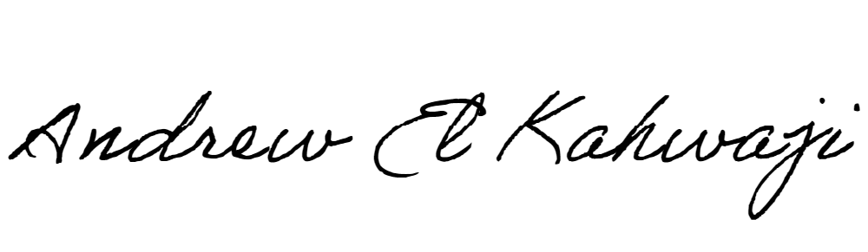

Printed Name _Andrew El Kahwaji_

Date __26/12/2024___

Email __andrew.lifesculptor.coo@gmail.com __

Phone __+961 71 914 378__